**Database Management System – cs422 DE**

**Lab 1 – Wk 3 & 4**

---------------------------------------------------------------------------------------------------------------

Solve the questions from 6.32 to 6.40 in the Case Study 2 on page no. 173 (5th edition).

You are required to run & test all these queries in SQL Server. Note that you’ll need to create and populate the tables first.

To get full credit for this lab, you need to submit the following:

1. Screenshots for at least 4 of the queries with output.
2. Answer SQL queries for all of the mentioned exercises.

For your quick reference, the schema and the questions are given below.

Employee (**empID**, fName, lName, address, DOB, sex, position, deptNo)

Department (**deptNo**, deptName, mgrEmpID)

Project (**projNo**, projName, deptNo)

WorksOn (**empID**, **projNo**, hoursWorked)

where

* *Employee* contains employee details and *empID*is the key.
* *Department* contains department details and *deptNo*is the key. *mgrEmpID* identifies the employee who is the manager of the department. There is only one manager for each department.
* *Project* contains details of the projects in each department and the key is *projNo*(no two departments can run the same project).
* *WorksOn* contains details of the hours worked by employees on each project, and *empID/projNo*form the key.

Tables I created for this lab with my test data are the followings.

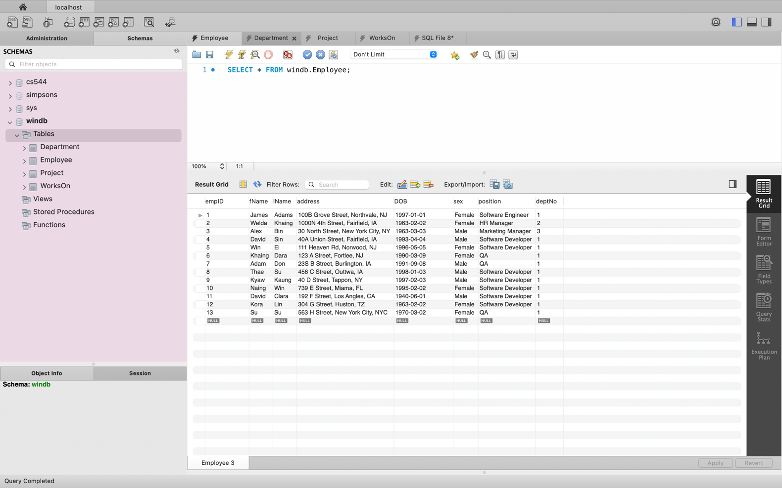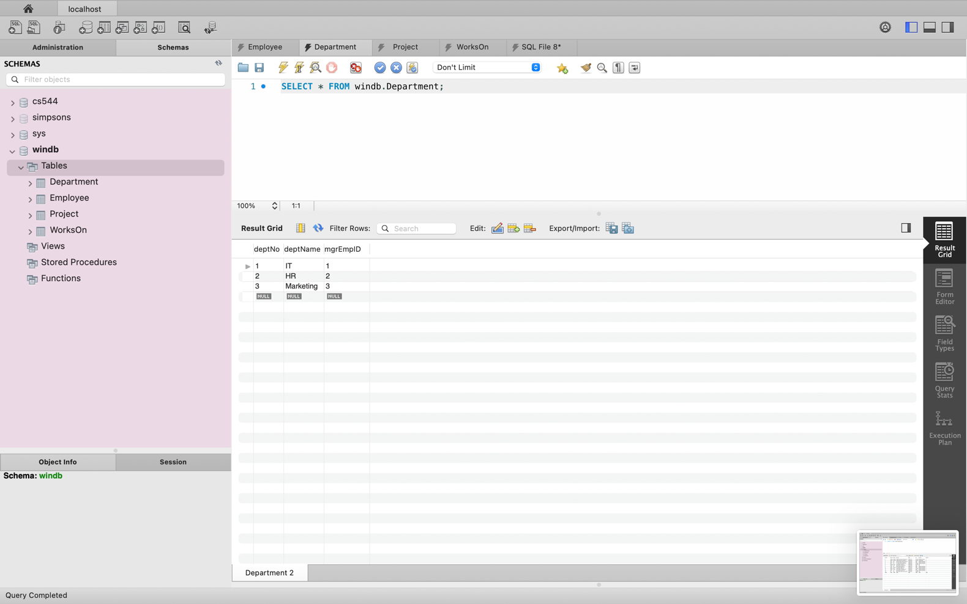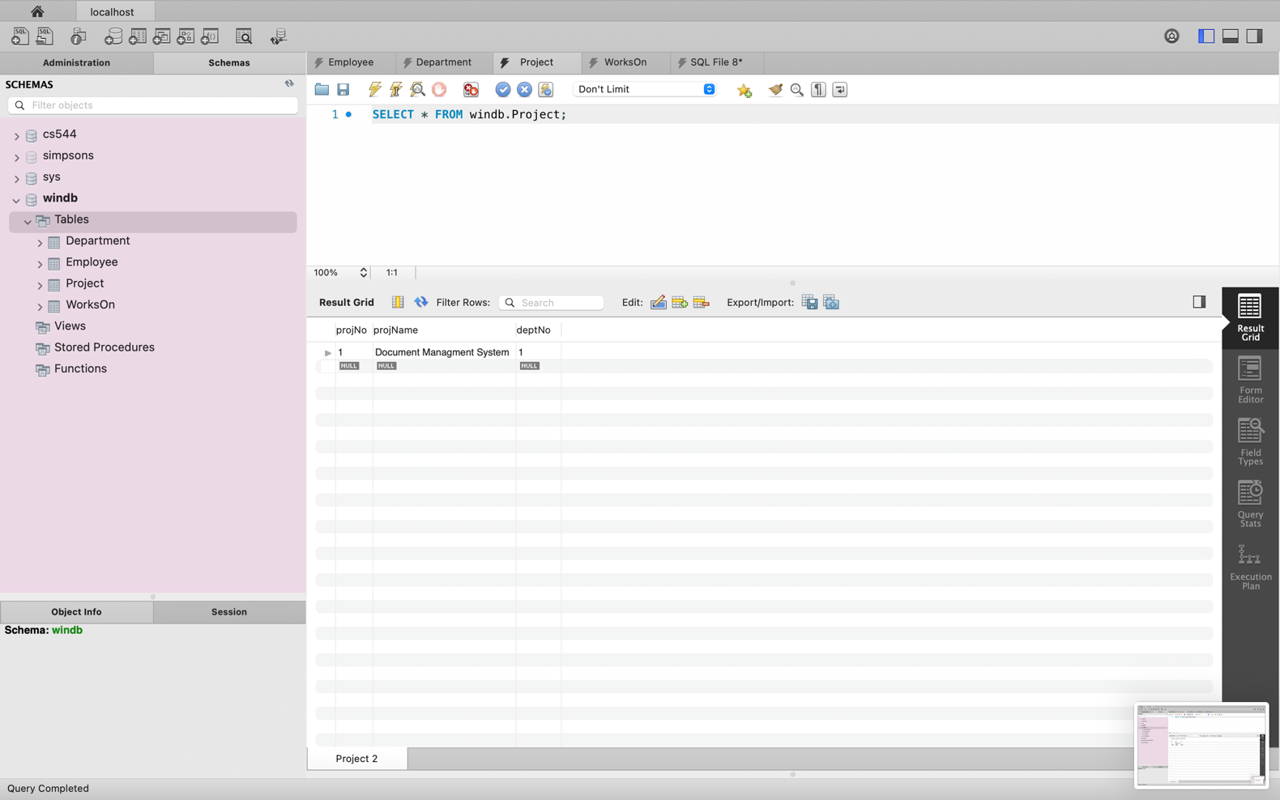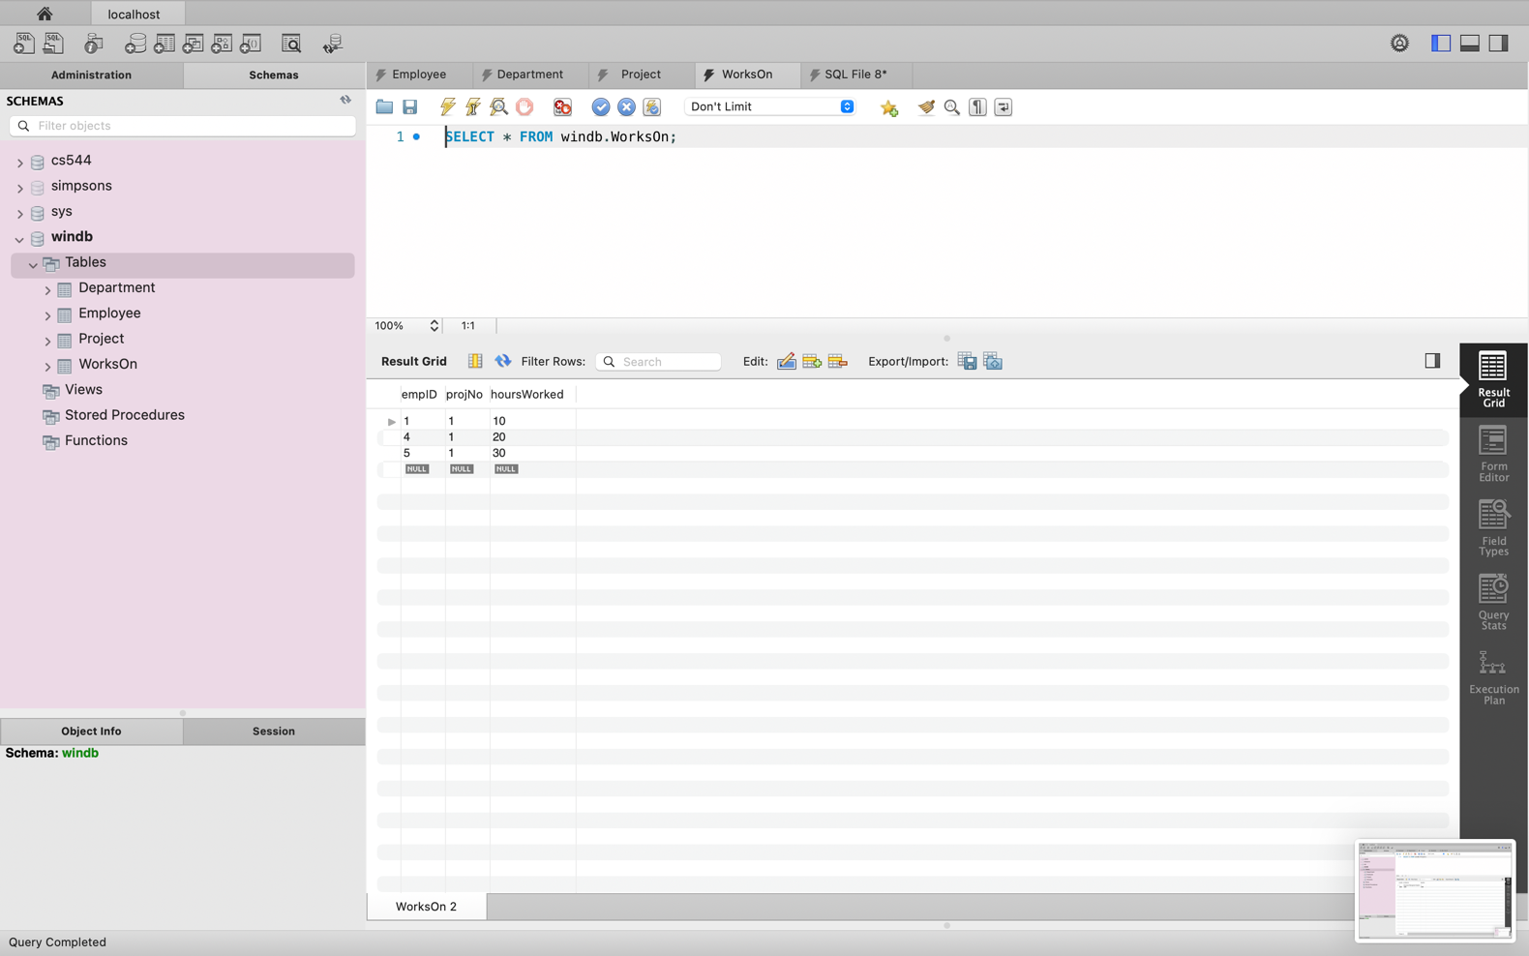

**Exercises**

1. List all employees in alphabetical order of surname and within surname, first name.

ANS:

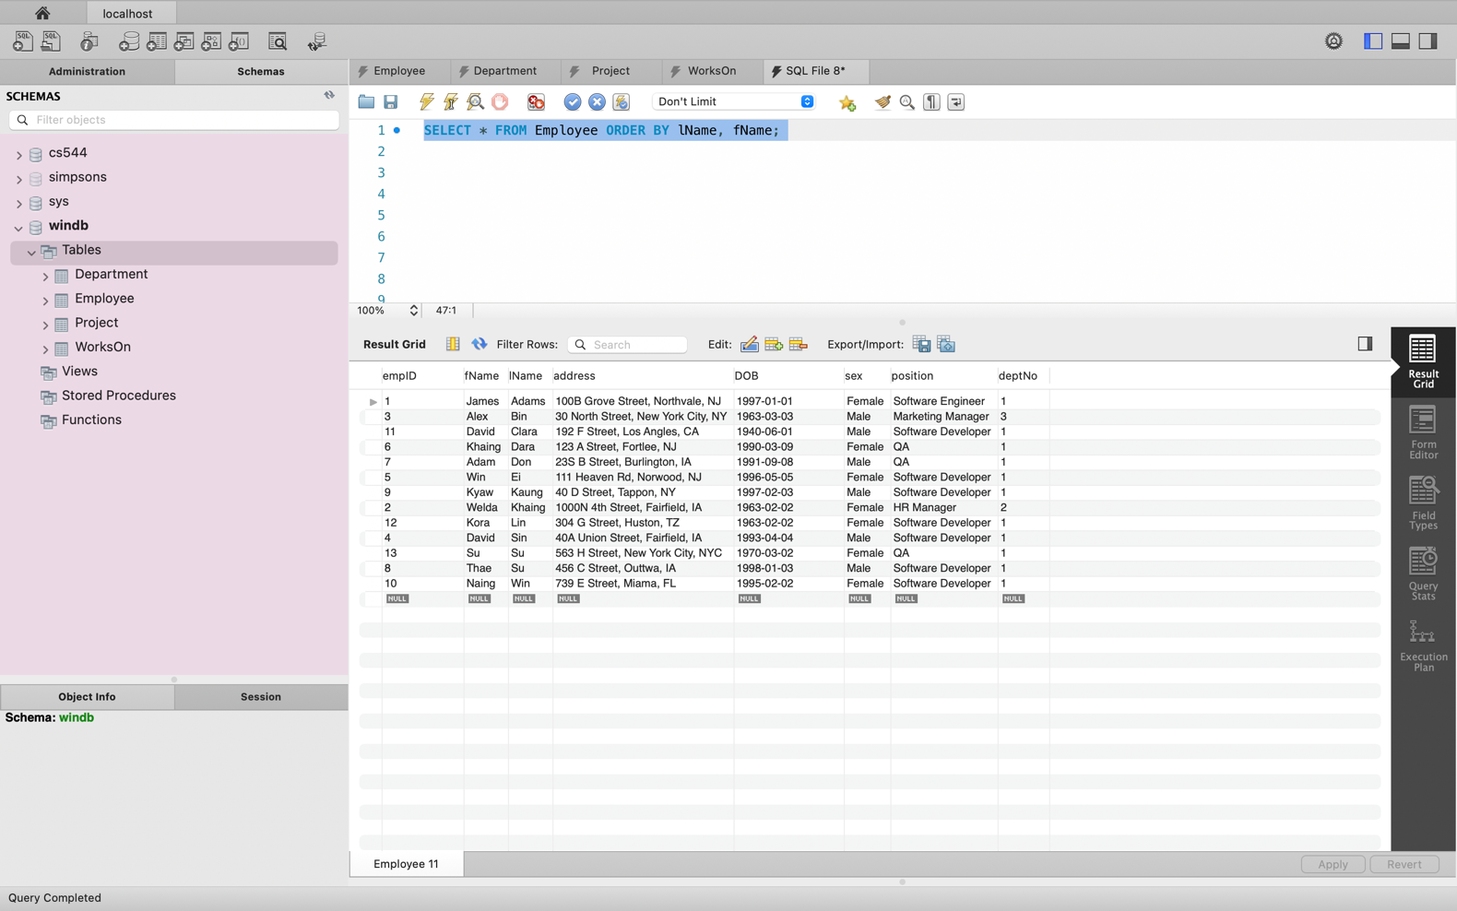

1. List all the details of employees who are female.  
   ANS:

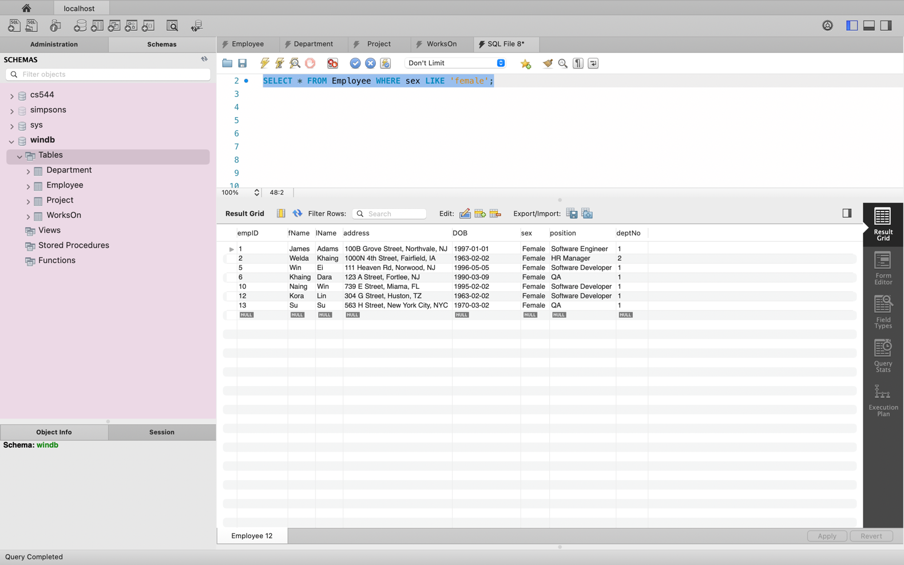

1. List the names and addresses of all employees who are Managers.

ANS:

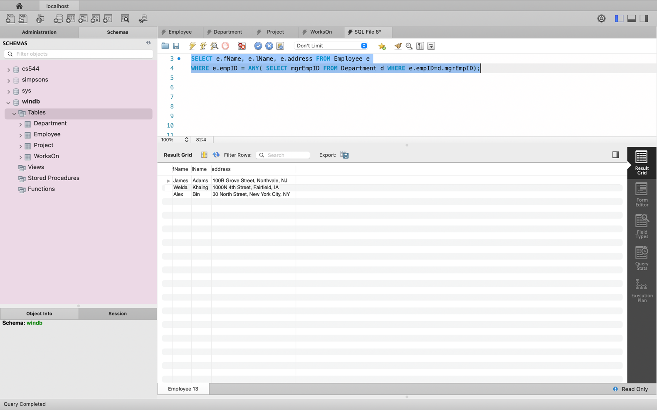

1. Produce a list of the names and addresses of all employees who work for the IT department.

ANS:

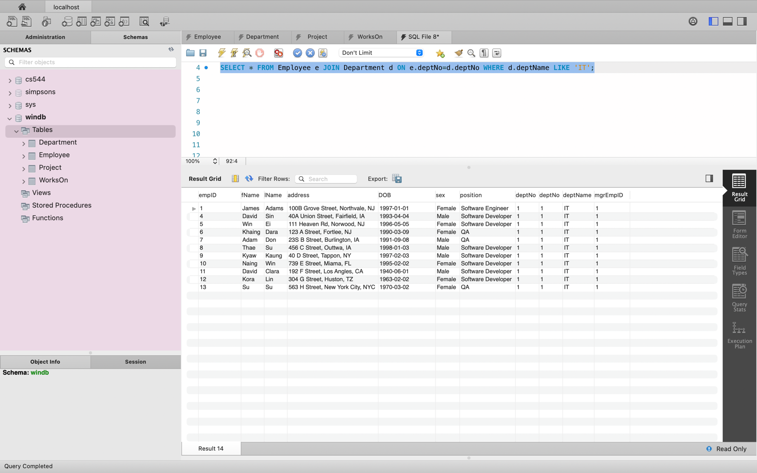

1. Produce a complete list of all managers who are due to retire this year, in alphabetical order of surname.

ANS:

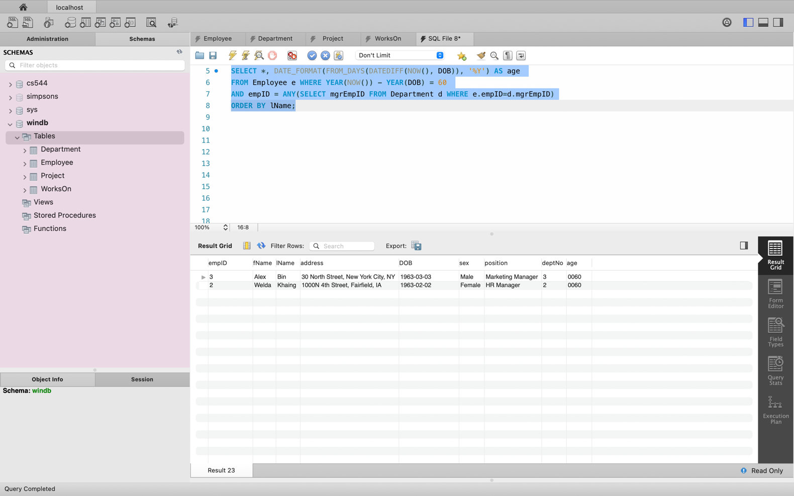

1. Find out how many employees are managed by ‘James Adams’.

ANS:

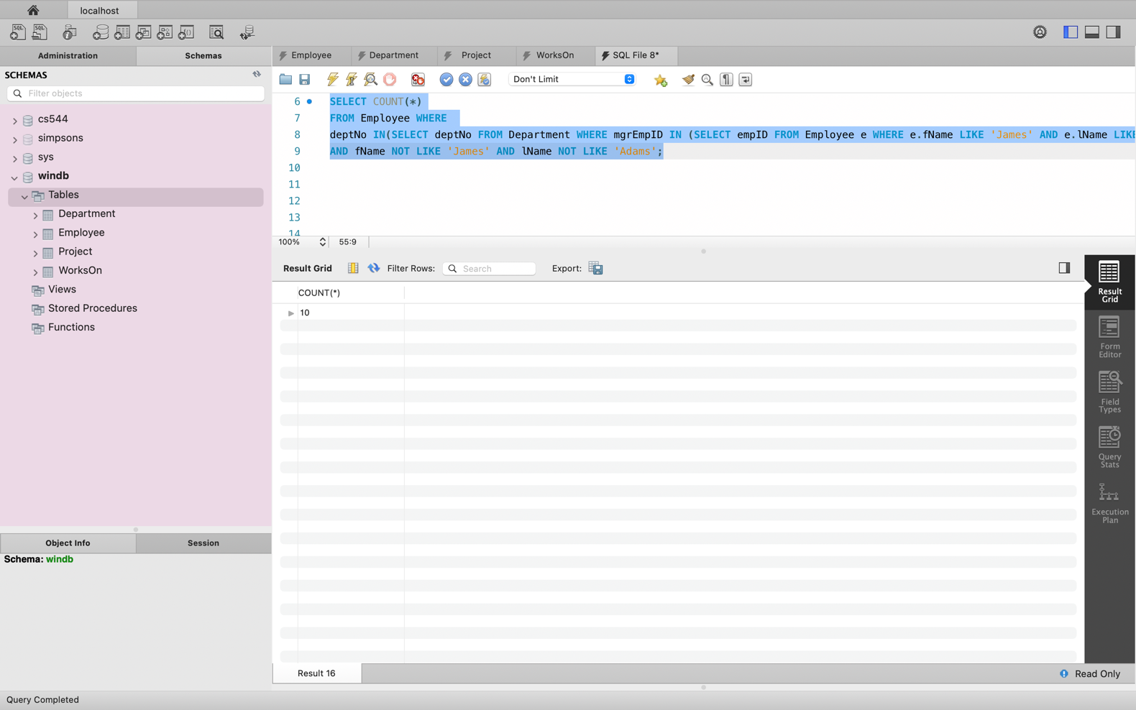

1. Produce a report of the total hours worked by each employee, arranged in order of department number and within department, alphabetically by employee surname.

ANS:

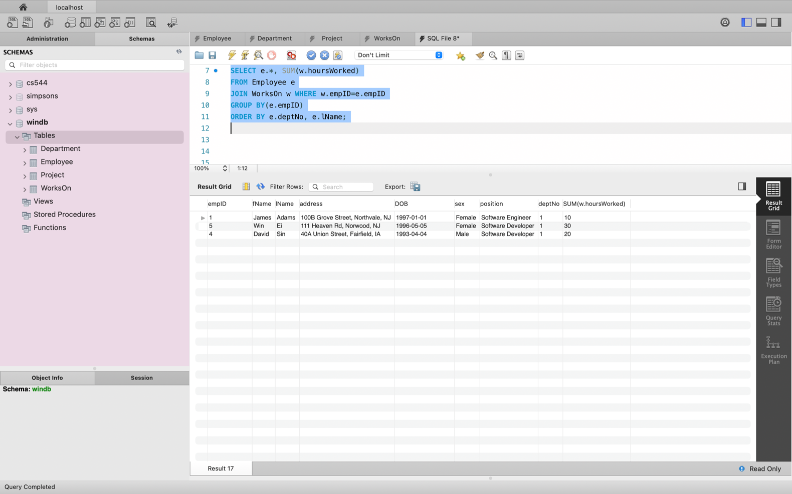

1. For each project on which more than two employees worked, list the project number, project name and the number of employees who work on that project.

ANS:

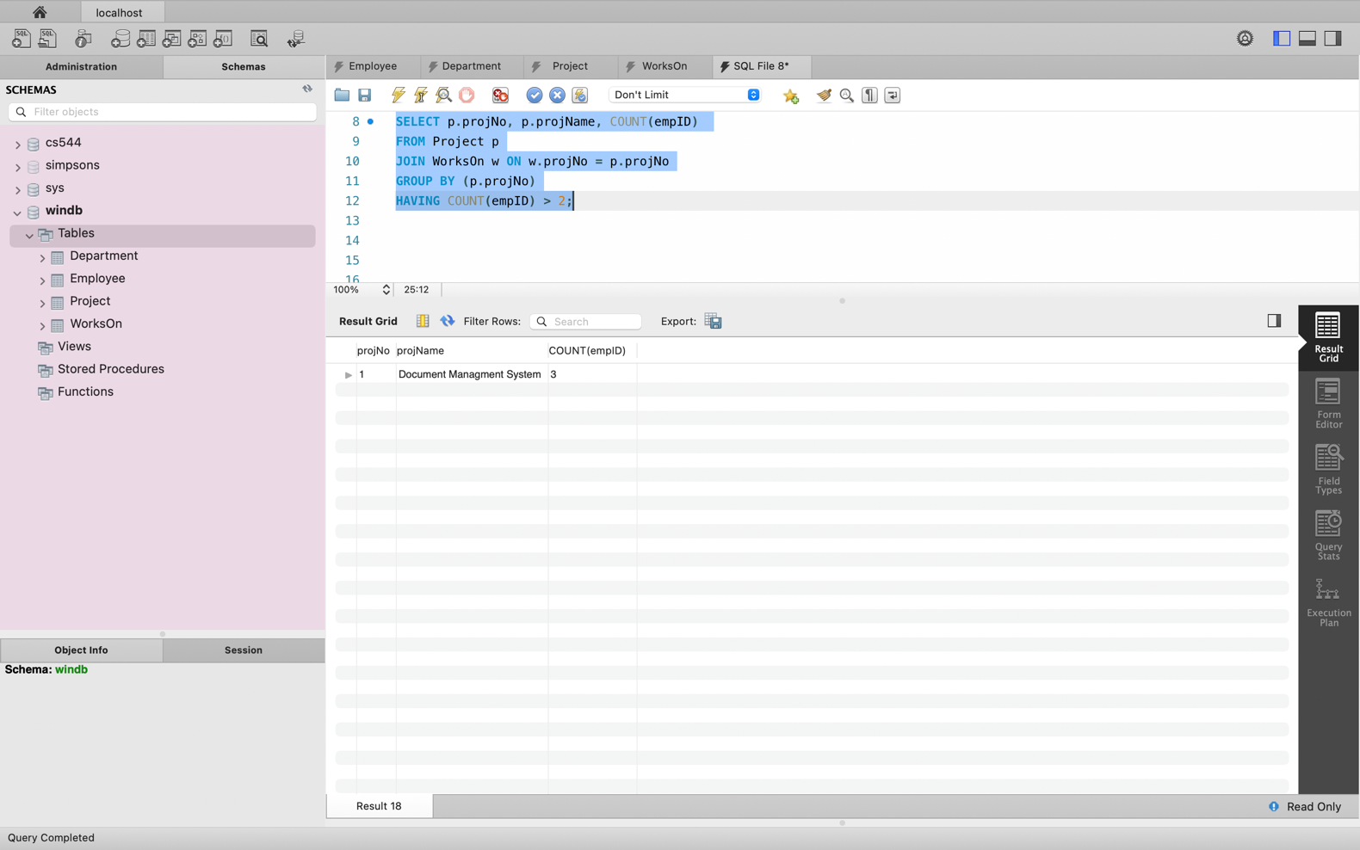

1. List the total number of employees in each department for those departments with more than 10 employees. Create an appropriate heading for the columns of the results table.

ANS:

